PART A – WEBSITE PLANNING & DOCUMENTATION

1. Website Specifications

1.1 Website Objective

The objective of the GameVerse website is to create a modern multi-page gaming platform that allows users to explore popular and trending games in an engaging and visually appealing environment. The website was designed to provide users with easy navigation, interactive features, and consistent page layouts while promoting gaming-related content.

The website aims to:
Provide users with information about popular games.
Create an attractive and modern gaming-themed interface.
Allow users to navigate through multiple pages easily.
Improve user interaction through forms, hover effects, and ratings.
Demonstrate the use of HTML5, CSS3, and JavaScript in web development.

1.2 Website Goals in Relation to the Business

The main goal of the website is to simulate a gaming brand that promotes games and engages users through modern web technologies.

The website supports the business by:
Promoting gaming content and featured games.
Creating a professional online presence for the GameVerse brand.
Increasing user engagement through interactive features.
Providing easy access to gaming information.
Building a visually consistent and responsive platform.

1.3 Target Audience

The target audience for GameVerse includes:

Teenagers and young adults.
Gaming enthusiasts.
Casual and competitive gamers.
Users interested in trending online games.

Demographics

Age Group: 13 – 30 years.
Gender: All genders.
Interests: Gaming, esports, online entertainment, multiplayer games.
Device Usage: Mobile phones, tablets, laptops, and desktop computers.

Technical Aptitude

The users are expected to have moderate to high technical knowledge because most gamers are familiar with websites, online platforms, and interactive systems.

1.4 Type of Website

GameVerse is an entertainment and gaming information website. The website focuses on gaming content, featured games, feedback interaction, and user engagement.

The website contains:

A homepage.
Games page.
Details pages for all games.
About Us page.
Contact page.
Feedback page.

2. Information Design & Taxonomy

2.1 Information Architecture

The information architecture of the website was designed to ensure that users can navigate through the website quickly and efficiently.

The website uses a consistent navigation bar across all pages to maintain page uniformity and improve usability.

The structure of the website is organized as follows:

Home Page

Introduction to the GameVerse website.
Featured and trending games.
Navigation to other pages.

Games Page
Displays game cards.
Provides access to game details.
Uses consistent card layouts.

Games details pages

Allows users to go directly to the desired game, where they are provided with more information about the game.
Provides link to the actual game

About Us Page

Explains the purpose and mission of the GameVerse brand.
Provides background information about the website.

Contact Page

Provides social media contact icons.
Allows users to connect with the platform.

Feedback Page

Allows users to submit feedback.
Includes form validation.
Includes a star rating system.

2.2 Site Map

Home ├── Games ├── About Us ├── Contact └── Feedback

Game
Details

2.3 Navigation Structure

The navigation system was designed to ensure that all pages are interlinked with no broken links.

Users can move between pages using the navigation bar located at the top of every page.

The website follows the 3-click rule, meaning users can access important content within three clicks or fewer.

3. Page Template Design

The website layout was designed using modern gaming-inspired aesthetics.

The page templates were planned using wireframes before development began. The design focused on:

Consistent navigation bars.
Hero sections.
Game card layouts
Modern typography.
Dark colour schemes.
Glowing effects and gradients.
Consistent spacing and alignment.

The homepage contains a hero section that introduces the GameVerse brand. The games page contains game cards displayed in a responsive grid layout. The contact and feedback pages use interactive sections and forms to improve user engagement.

The overall design aims to create a visually immersive experience that appeals to gamers.

4. Technical Brief

4.1 Technologies Used

HTML5
HTML5 was used to create the structure of the website. Semantic HTML5 tags such as:

header
nav
main
section
article
footer

were used to improve accessibility, structure, and readability.

CSS3
CSS3 was used to style the website and create the visual appearance of the pages.

CSS was used for:

Layout design.
Colours and gradients.
Hover animations.
Card styling.
Navigation styling.
Responsive layouts.
Typography.
Buttons and forms.

JavaScript
JavaScript was used to add interactive functionality to the website.

Examples include:

Form validation.
Interactive star rating system.
User interaction improvements.

4.2 Software Tools Used

The following tools were used during development:

Tool Purpose

Visual Studio Code Code editing and development
GitHub Repository hosting and version control
GitHub Pages Website publishing and hosting
Web Browsers Testing and debugging
Font Awesome Social media and interface icons
Image Editing Tools Creating and editing graphics and logos

4.3 Graphics and Multimedia

Custom images, gaming banners, logos, and icons were used to improve the appearance of the website.

Images were optimized and positioned carefully to maintain visual consistency.

5. Quality Assurance

The website was tested to ensure that all pages function correctly across multiple devices and browsers.

5.1 Browser Compatibility Testing

The website was tested on:

Google Chrome(Mobile)
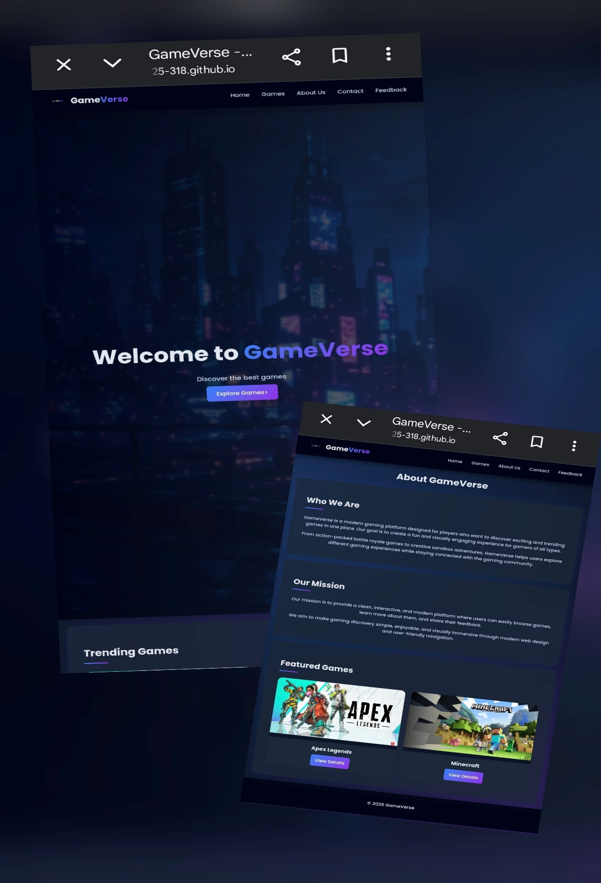

Microsoft Edge
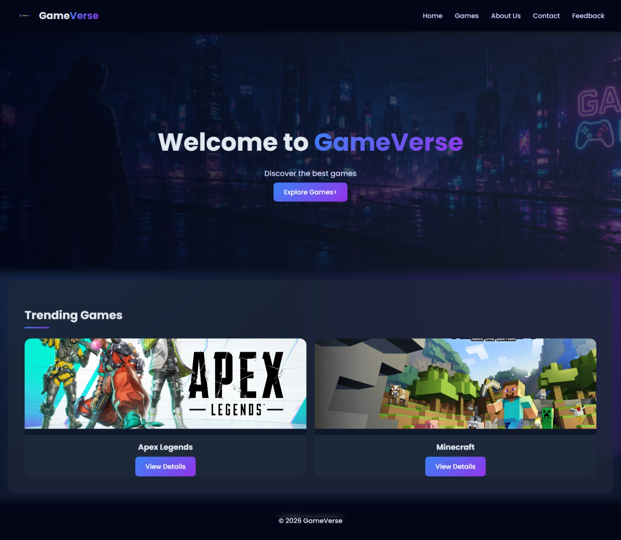

The following elements were checked:

Navigation links.
Image loading.
Form functionality.
CSS styling.
Hover effects.
Responsive layouts.

5.2 Mobile Device Testing

The website was tested on different screen sizes to ensure responsiveness.

The following were tested:

Mobile navigation display.
Responsive card layouts.
Text readability.
Button alignment
Image scaling.

5.3 Form Validation Testing

The feedback form was tested using HTML5 validation.

Validation checks included:

Required fields.
Email format validation.
Empty form prevention.
User-friendly validation messages.

5.4 Link Testing

All navigation links were tested to ensure there were no broken links between pages.

6. Publishing & Promotion

6.1 Website Hosting

The website was hosted using GitHub Pages.

GitHub Pages was used because it provides free website hosting for static websites and integrates directly with Git repositories.

6.2 GitHub Repository

A GitHub repository was created to store and manage all website files.

The repository contains:

HTML files.

CSS files.

JavaScript files.

Images and multimedia.

6.3 Git Commands Used

The following Git commands were used during development:

git init
git add .
git commit -m "Initial website upload"
git push origin main

6.4 Website URL

GitHub Repository URL:

https://github.com/cse25-318/WMD-Assignment.git

GitHub Pages Website URL:

https://cse25-318.github.io/WMD-Assignment/

7. Future Developments / Recommendations

Although the website is fully functional, there are several improvements that could be implemented in the future.

Possible future developments include:

Adding a user login and registration system
Adding a game search feature.
Integrating a database for storing user feedback.
Adding game trailers and embedded videos.
Creating a dark/light mode toggle.
Adding live chat or community discussion features.
Improving mobile responsiveness further.
Adding more interactive animations and transitions.

These improvements would enhance user engagement and make the website more dynamic and feature-rich.

Conclusion

The GameVerse website successfully demonstrates the website planning, design, development, and testing process using HTML5, CSS3, and JavaScript.

The website provides a modern and visually appealing gaming platform while maintaining consistency, usability, and responsive design principles.

The project demonstrates the effective use of semantic HTML5 tags, external CSS styling, interactive features, and GitHub Pages publishing techniques

Wireframes
